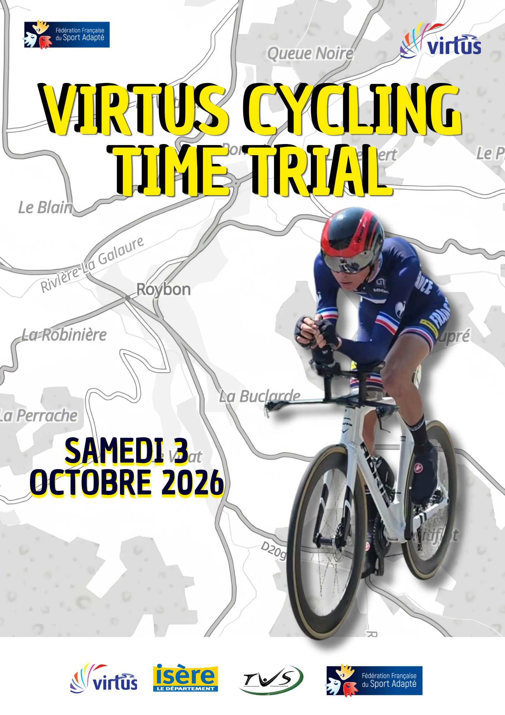
3rd International Isère Adapted Sport Challenge Time Trial

La Tronche Vélo Sport will be organising the 3rd Adapted Sport Time Trial :

Saturday, October 2026 the 3rd
Place St Romme
In Roybon (38360)

Following the two first editions organised in 2024 and 2025, we are relaunching the Adapted Sport Time Trial this 2026 season. This event will be supported by the Chambarans Time Trial (a FSGT race). An international Virtus event will be launched, the Virtus Open Cycling Time Trial.

Schedule:

- 10:00 am. : Welcome – Race number collection (Place St. Romme)
- 12:00 pm. – 3:00 p.m. : Adapted Sports Race
- 3:00 pm. : Award ceremony (Place St. Romme)
- 4:00 pm. : End of the event

Race Regulations
Race : 17.3 km / 241 m elevation gain
Road not closed, signalmen at each intersection
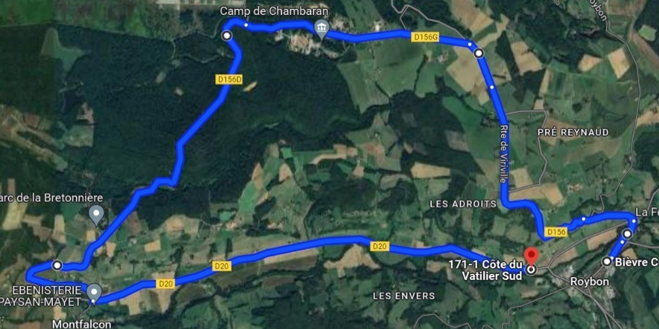

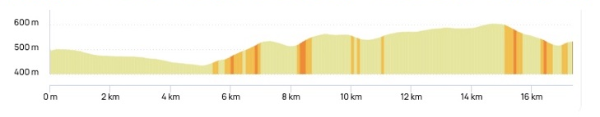

It will be possible to recognize the road the race day between 10:30 a.m. and 11:45 a.m.

ELIGIBILITY AND ACCREDITATION

- All athletes competing for the race must appear as “Active” on the Virtus Master List no later than the final entry deadline
- Applications for new athletes must be submitted to Virtus as soon as possible
- Athletes who do not meet the qualifying criteria or do not appear on the Virtus Master List as “Active” are not eligible for this event
- There is no guest entry

According to the rules of Virtus, the competition is opened to the following Virtus’ categories

- II1 – Athletes with an intellectual disability
- II2 – Athletes with an intellectual disability and significant additional impairment
- II3 – Athletes with autism

Equipment
Each participant must bring their own equipment. A time trial bike is not compulsory. You can use a standard road bike. A helmet and gloves are mandatory.

Registration
Registration will be completed using the attached Excel file and sent by email to gilles.richiero@orange.fr before August 1, 2026.

How to get to Roybon
Travel by plane : Lyon St Exupéry (LYS)
Travel by train : Grenoble Train station

Transportation to the race location is not covered by the organization. You will be responsible for your own accommodation, meals, and transportation.

Registration Fees
The registration fees include:
- Race registration
- Refreshments

The price is €40/person.

Food and Accommodation
Lodging contact information is available at :

- Tremplins Sport Formation in Voiron – website : https://www.tremplinsportformation.fr/ resa@tremplinsport.fr / Tel: +33(0)4 76 67 04 05
- Domaine de Château Rocher in Roybon - Tel: +33(0)4.76.36.20.98 - +33(0)6.75.49.18.51 info@gite-isere.com / website : https://www.gite-isere.com/
- Chambaran Natural Park in Saint-Pierre-de-Bressieux / Website : https://www.parcdechambaran.fr/contact-acces
- Camping lac de Roybon - campingdulac@onlycamp.fr / +33(0)7.59.64.06.17
https://www.camping-lac-roybon.fr/

Contact : Gilles RICHIERO - gilles.richiero@orange.fr – Tel : 06 61 97 16 90

